

MyLion Desktop Manual

INDEX

How to Access MyLion and Sign In 3

Welcome Lions Page 4

Home 5

New Activity 6

Report Activity 10

My Activities 12

Metrics 13

Shop Lions International 14

Insights 15

### How to Access MyLion

Welcome to LCIF’s MyLion. Using a laptop or a desktop computer key in the following web address:

[**http://lci-auth-app-prod.azurewebsites.net**](http://lci-auth-app-prod.azurewebsites.net/)

If you entered the address correctly you should see the below screen.

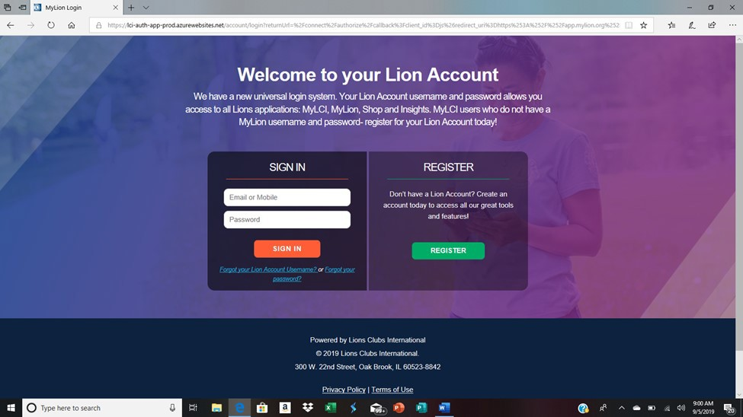

Next, enter your **Username and password**. (Write this information down for future use. ) Don’t hesitate to write it in the screen above. The username and password is the same whether you use your desktop computer, laptop or mobile device. So write down your username and password so you can remember it.

Click on Sign IN

**Welcome Page**

Once you have a successfully logged in this is your welcome screen. This screen will be different depending on your permissions. If you are a District Governor, President, Secretary, your screen may look identical to the below screen. If you are just a Lion member you may have all Columns except the MyLCI. It just depends on your permissions and what you are assigned to do within your club.

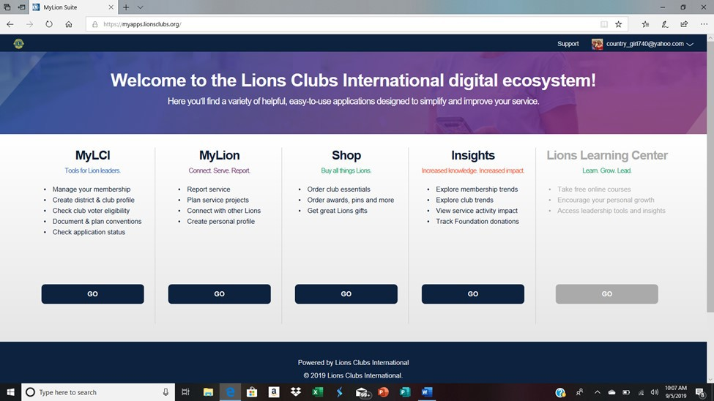

So next we are going to review everything except what is under the MyLCI column. In the MyLion Column

#### STEP 1: Click on GO.

**Home Page**

This is your Home screen. This is what your club is doing at a glance.

Example: The screen shows there where 250 people served but I want to know what activities we served them.

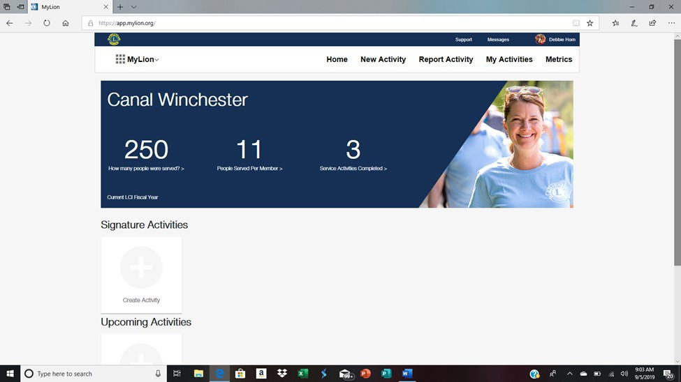

From here you can **export** the report if you want just click on the button. To get back to the begin- ning, use your **scroll bars** and scroll up or click on your **HOME link**.

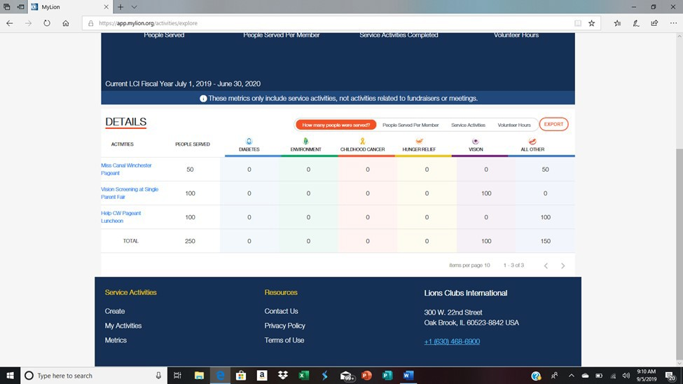

export

Scroll bars

#### New Activity Link

* **Click on the New Activity Link**:

Under this Link you have several different activity types you can set up. You can set up a Service Activity, Funraiser Activity, or a Meeting. No matter which one you choose the process is the same. So for this

scenario we are going to choose the Service Activity.

**STEP 1: Click on Service Activity** (there should be a red box around it)

**STEP 2: Click on Continue**

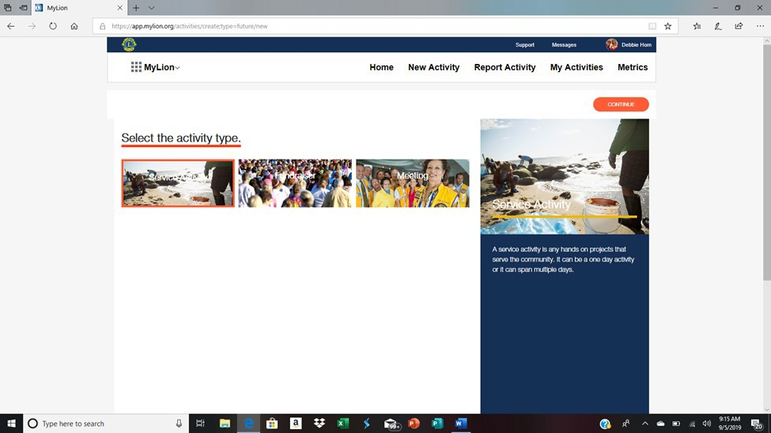

Step 1

Step 2

**STEP 3: Click on** the Cause of your activity (there will be a red box around whichever box you choose)

**STEP 4: Click on** Continue

**STEP 5: Click on** Project type ( there will be a red box around whichever box you choose)

**STEP 6: Click on** Continue

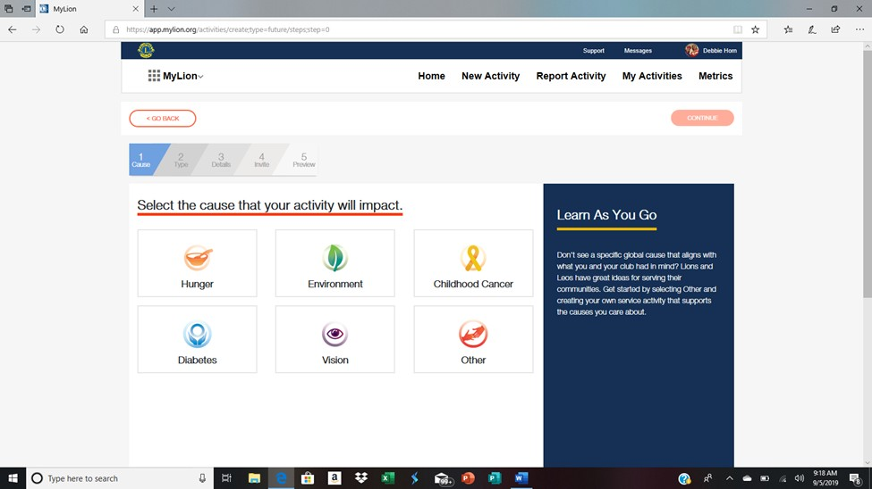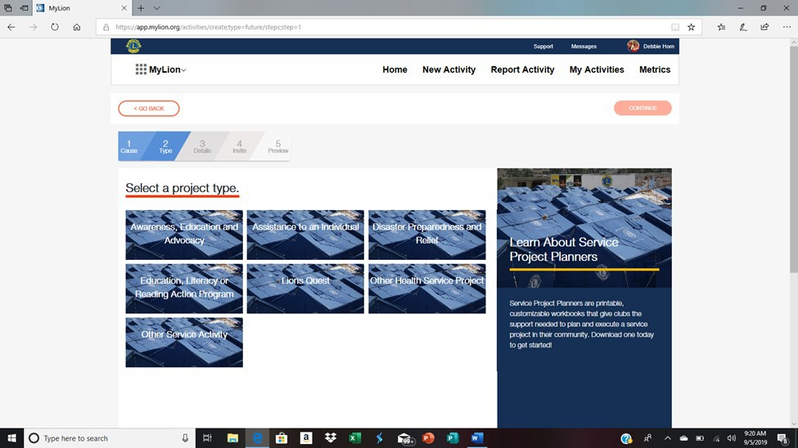

**STEP 7:** Complete the Fields for the Activity. Give as much as detail as you can. Under your **Privacy Settings**, you set who see your activity.

#### NOTE: If you change the default image and download your own, it may take some time. The system seems to get hung up.

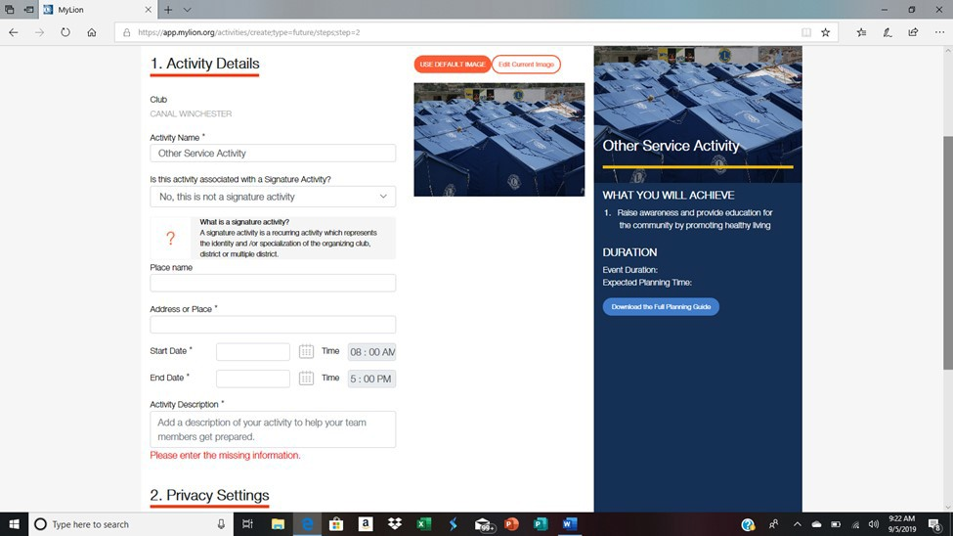

**To upload the image:**

**STEP 1: Click on** the Edit Current Image button

**STEP 2: Click on** the Select image button

**STEP 3: Navigate to** where your image is stored on your computer

**STEP 4: Click Save** Image ( Your Image should show in the box. If it does, follow the steps again until it does)

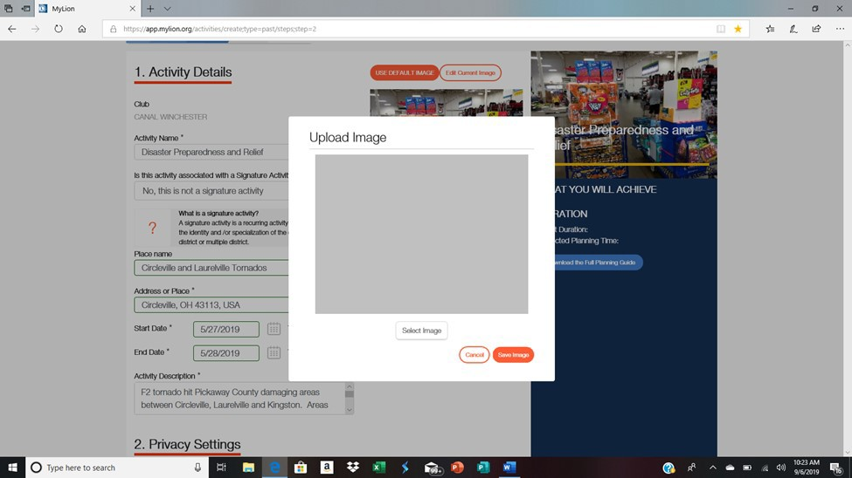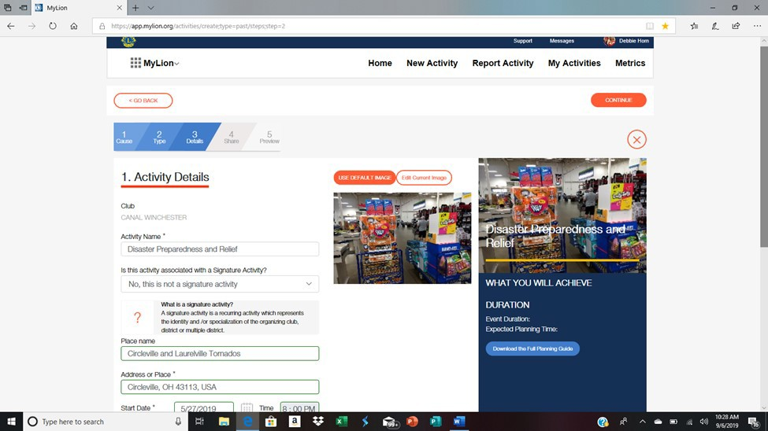

Report Activities

Depending on your permissions you may not have the ability to enter reports . You may only be able to **review Reports only**. This section covers both the ability to enter reports and

review reports.

#### STEP 1: Click on the Report Activity Link



If you only have limited permissions your view will look like this. You will only be able to review all the reports that your officers enter into the system. **Click on the Report you want to review**.

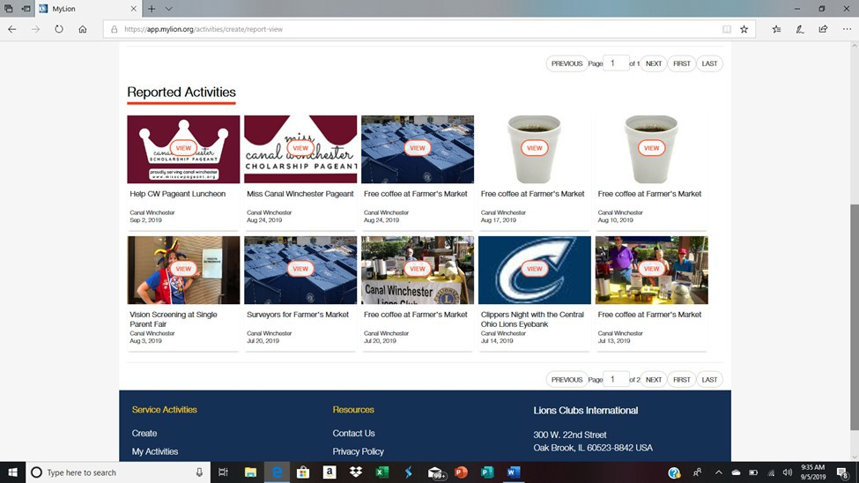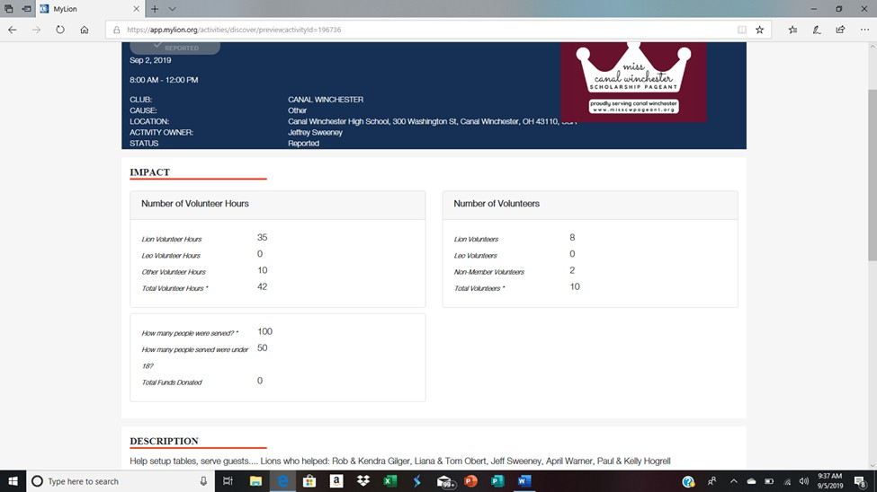

When you are done reviewing your report you can scroll down your screen until you find your **GO BACK** button and click on it or use your **scroll bars** and scroll up and click on your **HOME LINK**.

## Creating a Report

**STEP 1:** Click on the Report ActivityLink

**STEP 2:** Click on the button Create Past Activity to Report

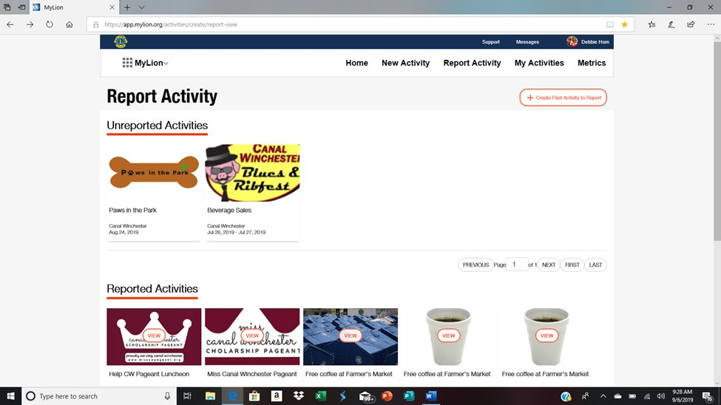

**STEP 3:** Click on an Activity type. (whichever one you choose will have a red box around it.)

**STEP 4:** Click on Continue

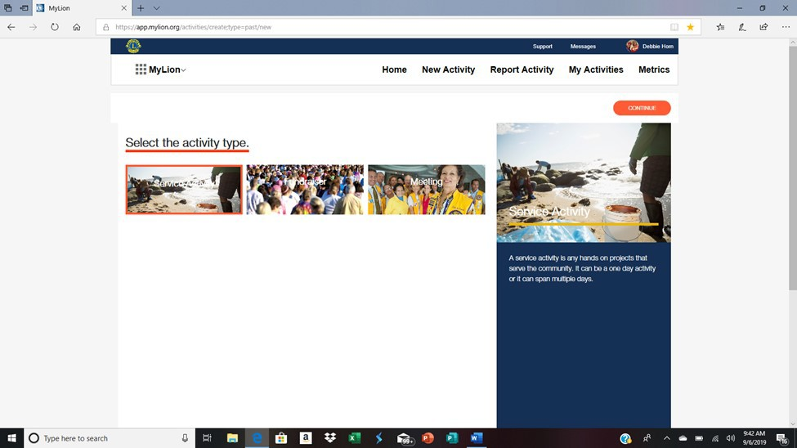

**STEP 5:** Click on the Cause of your Activity (a red box will appear around your choice)

**STEP 6:** Click on Continue

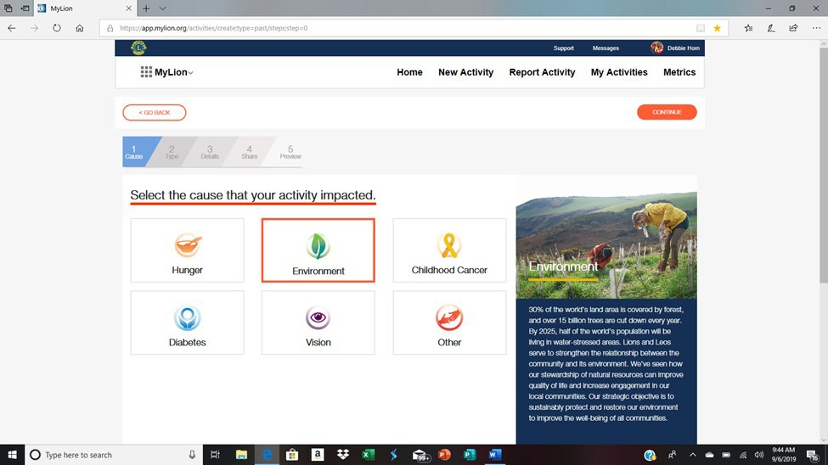

**STEP 7:** Click on a project planner that applies. ( a red box will appear around your choice)

**STEP 8:** Click on Continue

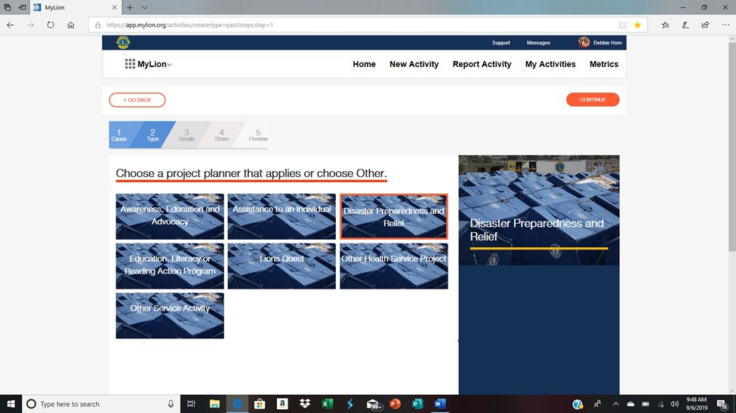

Complete **All** the fields that have an “**\***” . The more information that is entered the better for

your club members to see what is going on in your club.

##### **NOTE: If you download an image the system seems slows. So if you don’t mind their photos you can use their default photos.**

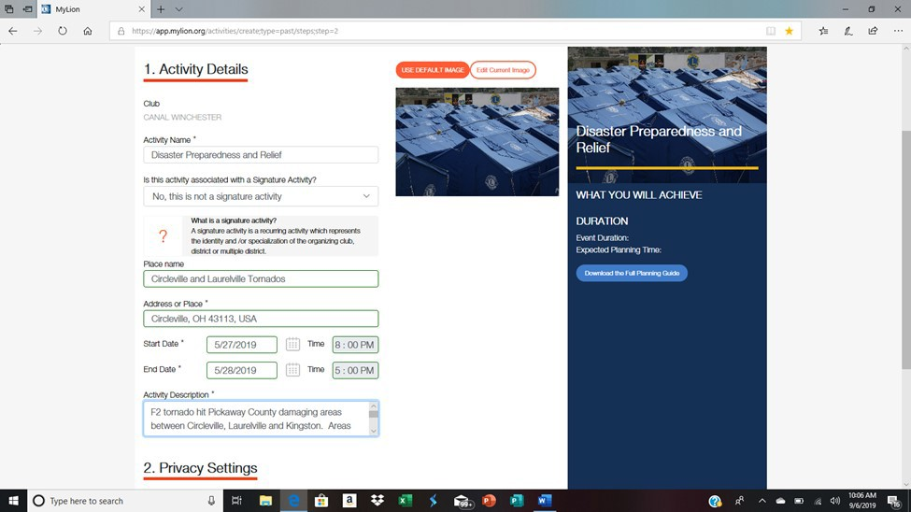

**To Upload /download an image STEP 1:** Click on Edit Current image

**STEP 2:** Select Image

**STEP 3:** Navigate on your laptop/desktop where your image is that you are downloading.

**STEP 4:** Click Open ( not pictured. This step is from step 3 where you are navigating to your laptop/desktop image)

**STEP 5:** Click Save Image ( your Image should show in the box. If it doesn’t follow steps 1-5 again.)

**STEP 6:** Click Continue



**Complete all the fields on form.** When you are finished

**Click on the Continue button.**

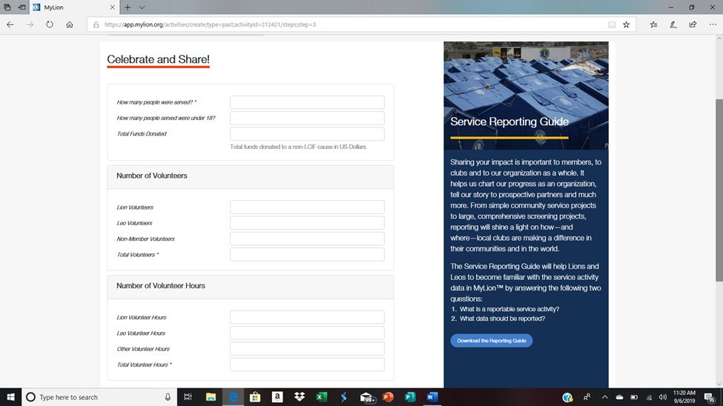

Review your Report . Once you are finished reviewing your report

#### Click on the Report button.

##### **NOTE: If you click on the GO BACK button or the “x” button you will have to start from the beginning.**

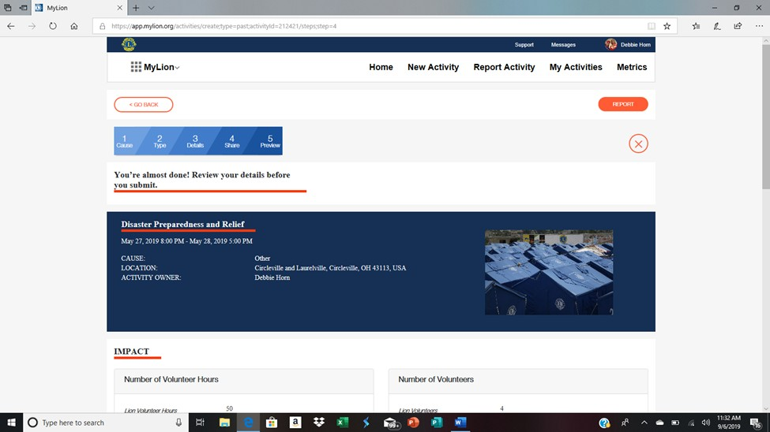

My Activities link

**Click on the My Activities link**. If you have any Activities this is where they will show up. To view the details just **click on the Activity**.

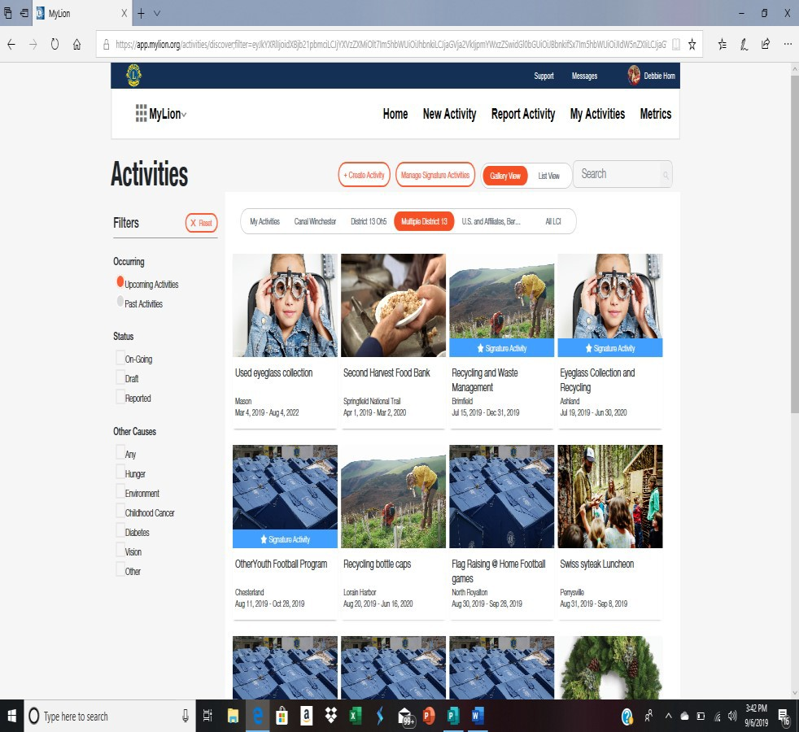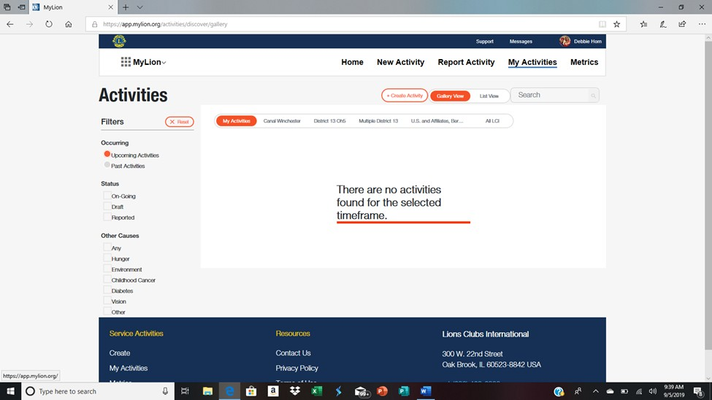

No Activities List of Activities

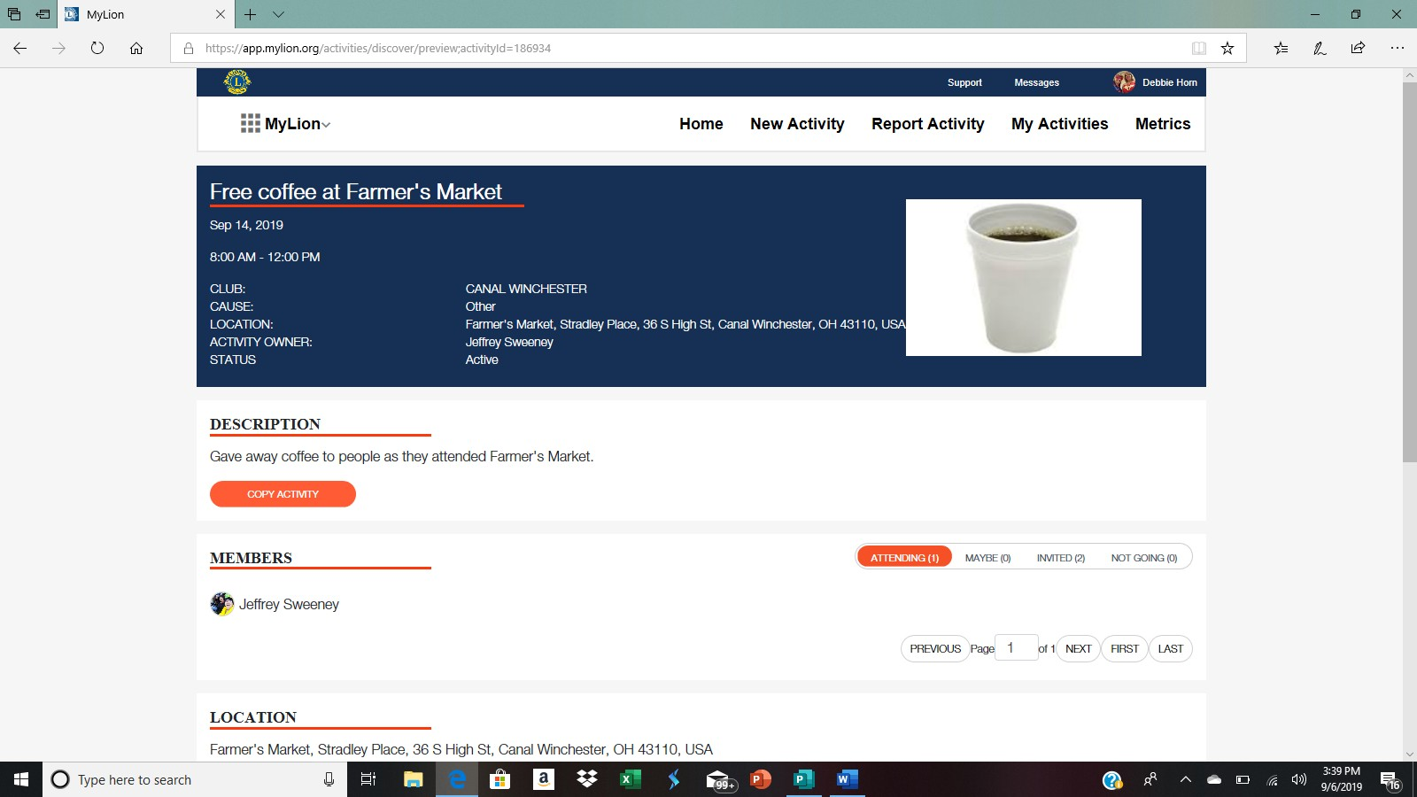

Details of Activities

#### Click on the Metrics Link

# METRICS

The Metrics gives you the overall report of everything your club has been involved in and the categories that everything has been reported to LCIF.

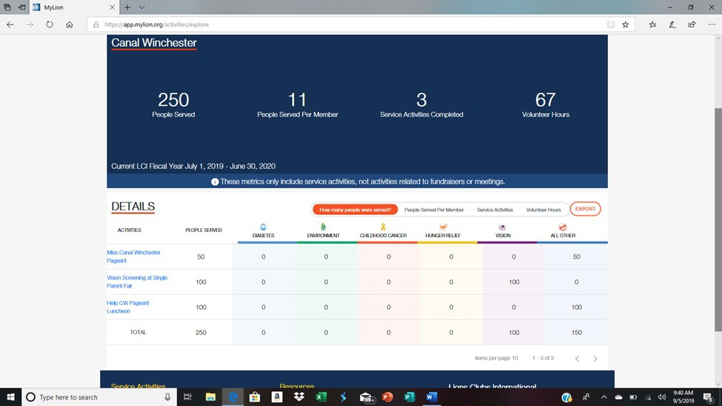

## The Shop Column

The Shop Column– Everything you can purchase online at Lions International

##### Have FUN SHOPPING!!!!

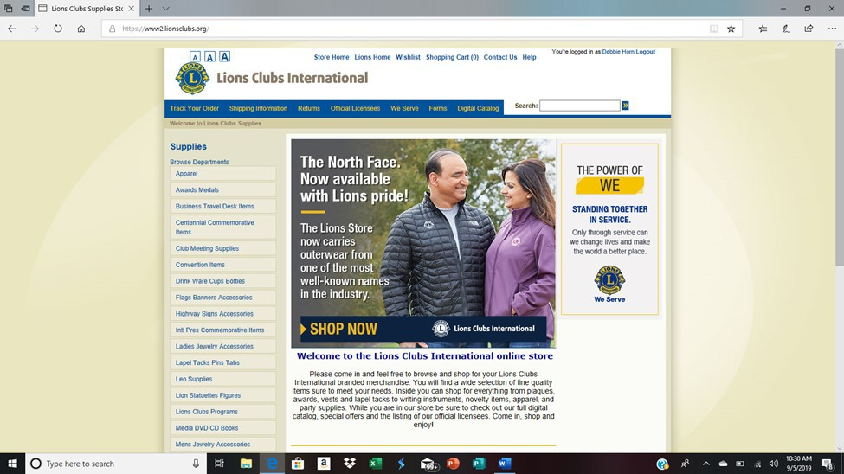

Insights Column.

This report shows you the trends throughout Lions. We can track the donations to LCIF.

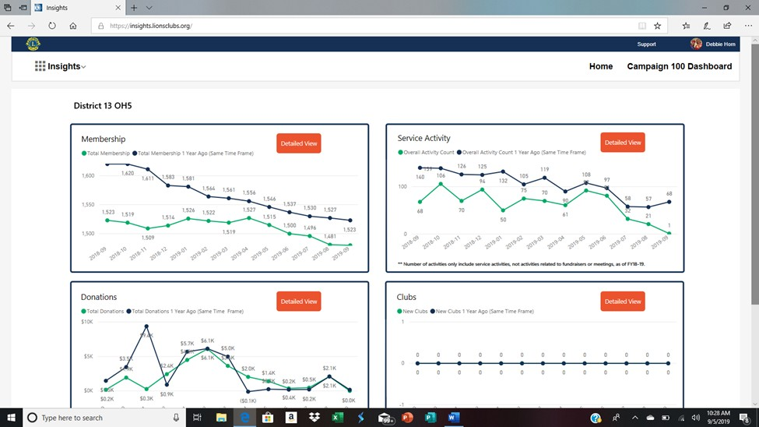

*NOTES:*

*If you need assistance or have any questions please contact :-*

*Harold Cover (Wodonga)*

*Email:* [*hcover@bigpond.com*](mailto:hcover@bigpond.com)

*Mobile: 0408 901 606*

*Cabinet Secretary Lee Walkington (Cohuna)*

*Email:* [*cabsec.v6@lions.org.au*](mailto:cabsec.v6@lions.org.au)

*Mobile: 0400 576 383*